Technical Document

B00315699, B00304870, B00308699

University of the West of Scotland

Games Design

Contents

Project Overview 4

Game concept 4

Technical goals 4

Primary Goals: 4

Secondary Goals: 4

Tertiary Goals: 4

Technical risks 4

Game Engine 4

Platforms 4

Gameplay 5

Game structures/game objects 5

Physics 5

Goals 5

Skill trees 5

Game World 6

Design 6

Game Objects 6

Human 6

Creatures 6

Ships 6

Weapons 7

Player Weapons 7

Pistol 7

Fists 7

Sword 7

Hook Hand 7

Parrot 7

Boat Weapons 8

Cannons 8

Mortar strikes 8

Multiplayer 9

User interface 10

Game Menus 10

Main Menu 10

Options menu 10

Player Inventory 11

Skill trees 11

In-game controls 12

Controller maps 12

Movement 12

Looking Around 12

In-Game menu 12

Death screen 12

Win Screen 12

Audio 13

Features 13

Volume control 13

Speaker settings 13

Headphones 13

Appendices 14

# Project Overview

## Game concept

In the game the player will take on the role of a pirate as part of a pirate crew. They can either play solo by themselves or online co-op with friends as part of a crew. The player may choose to progress through story based quests or explore the world and battle other crews.

## Technical goals

The following are technical goals we wish to achieve in the game:

### Primary Goals:

* Ground-breaking 3D graphics.
* A large detailed open world.
* High Quality water effects and realistic physics.
* Immersive sound design.
* Well-designed user interface.
* Collision physics.
* Smooth controls for operating boat.
* Competent AI.
* Detailed character models and animations.

### Secondary Goals:

* Realistic boat collision physics.
* High Quality AI.
* Custom camera settings.

### Tertiary Goals:

* Custom graphic settings on console (FOV, framerate).
* Mod support.

## Technical risks

* Having realistic water physics may be difficult to optimise for all platforms.

## Game Engine

The Game will be developed in Unity, we will utilise the full power of the engine to fully capture our vision.

## Platforms

Current platform goals:

* Windows
* Mac OS
* Playstation 4
* Xbox One

# Gameplay

## Game structures/game objects

* The game will feature interactable objects such as guns and a ships control which the player will allow the player to manoeuvre and defeat enemy units and ships. Players are able to move around and explore their ship/Homebase and interact with NPC characters and world objects in the same way outside of missions.

## Physics

* For the game we will develop an all new system for the games water effects. This will be designed to produce realistic waves and provide an accurate sailing experience. The system will be designed to respond to weather conditions as the ocean would in reality.
* The game will also feature realistic collisions for the in-game pirate ships, we want the collisions between boats and objects such as land and other boats to be accurate and impactful.

## Goals

* The goals the player will be given will be to progress through the story and defeating enemies as they go. They will able to upgrade skills however they however they choose to aid them as the game progresses and allow them to defeat enemies further into the game. The player will be able to play the game at their own pace and the game will feature an optional linear story arc.

## Skill trees

* Each character will share the same skill tree. However each unique character has one trait that only they can obtain (they start with). Every other skill can be accessed by all players in any order and at any time they choose. The skills will alter game play such as the repair skill will allow a player to repair broken areas of the ship at a higher rate when compared to other players. The Skills available are as follows:
* Repair: Every Point (up to 10) increased the speed at which the user repairs by 5%. At 5 points the user is able to repair by simply being near damaged objects but with 20 percent efficiency.
* Gunner: Every Point (up to 10) increased the fire rate and damage per shot by 5% while using a ships weapon.
* Medic: Every point (up to 10) allows a player to heal other players and interactable NPCS. The healing per second is increased by 10 percent up until level 5. From level every point results in an aura heal that heals per second.

# Game World

## Design

Given the games pirate focus the bulk of the game world will be open seas with land segments scattered throughout. Land segments can vary from natural islands that are populated by palm trees and sandy beaches, to strongholds that have a manmade look or modern structures that have been destroyed. The game world will visually be a mix of classic pirate media and modern/futuristic designs.

## Game Objects

### Human

The game world will be populated by human characters, both AI and player controlled. Standard AI characters will have around 150 health to allow them to be defeated relatively easily while standard player characters will have around 250 health. Players can potentially improve their health stats among others as they upgrade their character.

The game’s AI characters will act both as enemies for the player to defeat and as crew mates to provide assistance. Crew mates will be designed to operate components of the ship such as cannons if they are ordered by the player, they will also follow the player into combat situations if they wish. The AI will be capable of fighting enemies but are not too powerful so the player still has to work hard.

The player will also encounter enemy AI, in the games single player mode these act as the main opponents for the player and will be reasonably difficult to defeat. They will be capable of battling the player on both land and as part of a pirate ship. The AI’s difficult level will be able to be changed by the player in the games settings.

In the games multiplayer mode the AI characters will be present but will be slightly easier to defeat than in the single player mode in order to highlight player vs player combat.

### Creatures

The game world will be populated by creatures and monsters. These will act as bosses throughout the game and will be difficult to defeat. This will be felt by giving the monsters relatively high health, potentially around 1000 and such. The creatures will also deal more damage than any human characters which will require the player to upgrade their character in order to defeat the boss.

### Ships

The pirate ships in the game will act as a vessel that can transport large amounts of human characters. The ships will be capable of dealing large amounts of damage and can be used to combat various bosses. The ship’s health stat may be around 1000 to make it durable and efficient in combat. The ship may be upgraded by the player to make it stronger and more powerful.

# Weapons

## Player Weapons

### Pistol

* The pistol is the player’s standard ranged weapon. At very close range the pistol will deal around 75 damage to body and 150 for headshots.
* The damage will be reduced by a certain amount the further the player is away from the target.
* The default pistol will also take a few seconds to reload and is only capable of firing a single shot at a time.
* Potential in-game upgrades may increase damage and reduce reload times.

### Fists

* Most basic starting weapon.
* Each time attack button is pressed the player will swing one punch, can be pressed rapidly for quick attacks.
* Each individual attack will deal around 15 damage without upgrades.
* Can be blocked by the opponent.

### Sword

* Advanced melee weapon.
* Functions the same as the “fists” weapon but with different animations.
* Each individual attack will deal around 30 damage without upgrades.

### Hook Hand

* Advanced melee weapon.
* Functions the same as the “fists” weapon but with different animations.
* Each individual attack will deal around 25 damage without upgrades.

### Parrot

* Functions as a remote control “drone” type tool.
* Allows player to fly around the area and mark enemies and objectives.

## Boat Weapons

### Cannons

* Player can approach cannon and press the interact button to use it.
* Cannon can be aimed by rotating left and right or tilting up and down.
* Rotating and tilting speed is slow but may be improved with upgrades.
* Cannon fires cannonballs in an arc so the player must aim their shots well.
* Cannon takes around 10 seconds to reload by default.
* Each individual cannonball can provide up to 10% damage depending on the impact area.

### Mortar strikes

* Fired in an upwards arc
* More range than a standard cannon.
* Takes 20 seconds to reload by default.
* Deals up to 10% damage.

# Multiplayer

### Online Multiplayer

The online multiplayer will be set up in parties of 4 players. Users can either enter with a party of friends, or simply search for other online players to team up with.

Before a user enters a game, each player must choose their character for this game session, in the load screen it will display all of the online player’s character choices. Then the users must choose which area they would like to initially spawn into, they of course can travel to other locations once in game. If no one votes for a specific area or there is a tie in votes, the game will randomly choose an area for the party to spawn into.

Form here the part will be entered into one of many servers that will host online matches. The format of the online game will open world, meaning that crews can travel all over not only to find other crews/strongholds but also to explore the world. Periodically new treasure and side objectives will spawn all over the map. This is to give users different options on how they would like to play.

When a crew enters battle with an enemy crew it will highlight this rival ship as enemy and per the captains orders this will be the crew’s main focus. However, this does not mean that this is a closed off battle. If other crews stumble across the battle they can choose to either join in or simply wait and observe. By adding this element in opens the possibilities for many different play styles.

### Co-op Mode

The co-op mode will also be set up in parties of 4 players that can be made up of either friends or other online players.

Again before a user enters a game they must choose the character class they would like to use for this session. However, the first point where this mode differs is that instead of playing in an online open world, the players will be playing through a version of the story line. With this they must choose a start point to begin playing. To make this work we have to create a system, which is as follows: When choosing the level selection the part cannot select a level that none of the players have reached. And to choose a level at least 2 or more players in the part must have reached said level. However, even at this point if there is a tie vote in which map to play, the game will automatically choose the lowest level that all players have reached.

Once a start point in the story has been reached they part will play through as they would normally, completing quest and fighting in battles. The difficulty and health of the enemies will be slightly increased to account for the amount of players. And with each successful mission and battle the players will gain XP in the co-op mode to level up and upgrade their characters.

At the moment this mode is only playable through online multiplayer but we are considering the possibility of splitscreen play, this may be difficult due to technical limitations however. We are also considering the possibility of LAN play.

# User interface

## Game Menus

### Main Menu

The main menu will be a 2D menu which has the following choices:

* “Story Mode” – This opens the Story Mode menu.
* “Multiplayer” – This opens the Multiplayer menu.
* “Co-op Mode” – This opens the Co-op Mode menu.
* “Options Menu”- This opens the Options menu.
* “Quit” – Quits the game and return to console home screen

### Story Mode Menu

This is another 2D menu that will have the story’s main character in the background, detailing the following options:

* “Continue”- This will continue the last played game save (this will only be available if the user has previously played and saved the game.
* “New Game” – This will begin a new story mode.
* “Load Game” – This will show all previously saved games and allow the user to choose which to continue with (Again this will only be available if the user has previously saved two or more games)
* “Options” – This opens the Options menu.
* “Quit” – This will return the user to the main menu.

### Multiplayer Menu

This is another 2D menu that will detail a realistic pirate map, with the world map detailing all the players around the playing the game.

* “Find game” – This will allow the user to find an online match in whichever game mode they choose.
* “Customise Characters” – This will allow the player to view all their different character classes and customise their: appearance, upgrade stats and upgrade/change skills.
* “Invite Players” – This will open up player’s friend list/player search so they can add other players to their party and search for online games with a party.
* “Options” – This opens the Options menu.
* “Quit” – This will return the user to the main menu.

### Co-op Mode Menu

This is another 2D menu that will rotate between showing all of the base character types each time the menu is entered.

* “Find game” – This will either: search for other players to make up the 4 players required and create a new game or it will take the four players in a party and create a game. From here it will allow the party leader to choose which stage of the story they begin playing from.
* “Customise Characters” – This will allow the player to view all their different character classes and customise their: appearance, upgrade stats and upgrade/change skills.
* “Invite Players” – This will open up player’s friend list/player search so they can add other players to their party and search for online games with a party.
* “Options” – This opens the Options menu.
* “Quit” – This will return the user to the main menu.

### Options Menu

The options menu will be a standard options menu with options for: gameplay, video, audio, controls and online.

* Gameplayer is where the user can control the games difficulty and how the game will play.
* Video is for all visual controls and whether or not the user will add subtitles or even correct colour-blind options.
* Audio is where the user can control audio levels and such.
* Controls will show all the different controller schemes and also allow the user the customise controls.
* Online is where the user can check online status and NAT types etc.

## In-game controls

### Controller maps

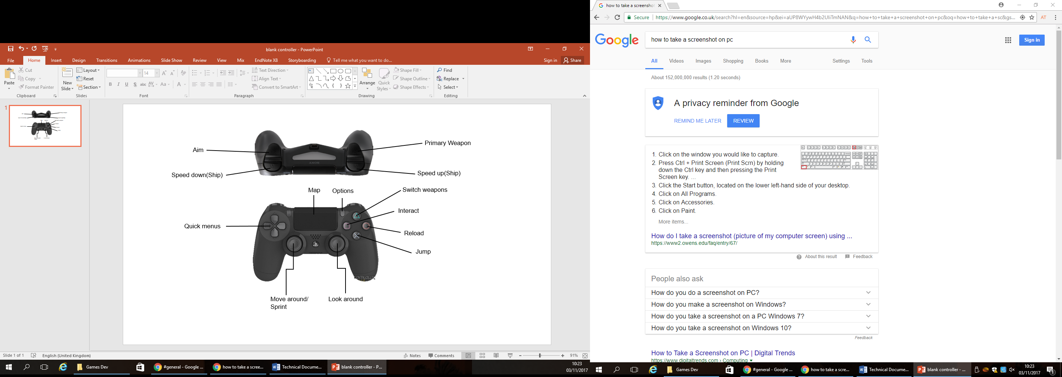

Our initial plan for the controller scheme will resemble the standard for most FPS games, but of course with differences being made to suit the game.

On the right is the initial mock-up of how we plan to map out the controls.

In the future we may alter this or even add completely different variations to suit each style of play.

### Movement

Movement in the game will follow the standard procedure of having it mapped to the left analogue stick. Of course pushing the stick either: forward, backwards, left or right will move the player in said direction.

By pushing in the analogue stick it will allow the user to change from normal movement speed into a sprint. This is beneficial as it allows the user to cover more ground more quickly.

### Looking Around

The game will use the standard of having the right analogue stick being used to control the camera. This will allow a full 360° range of view with very minimal movement from the user, unlike say they were using a mouse.

When a player is using either one of the ships weapons or even sailing the ship itself, it will change the range and scope of view. For example, when using one of the ships guns the user will be able to see further by zooming in but, they will be limited from side to side in how far they can look. This is to make it more realistic as guns can only be mounted to rotate a certain amount.

### In-Game menu

The in-game menu will be brought up by the user pressing the options button on the remote control they are using. This will then pause the game is single player but will only take the user out of the game in multiplayer, and show these options:

* “Resume” - Un-pause the game and return the user to playing.
* “Options” - This opens the Options menu.
* “Save Game” - This will save the users progress. **
* “Quit” - This will return the user to the main menu.

**Only apply to single player

### Death screen

When a player has been sufficiently damaged they will first have a red screen then they will go down and will have around 60 seconds for another teammate to revive them. If this does not happen the user will die and will be prompted with the option to either “wait for other players” or “Quit game”.

If they choose the wait option they will then spectate another member of the ship until either they win the battle and can return to a safe haven to allow other players to respawn or until all members die and it is game over. If they do choose to rely on their teammates and they successfully respawn, they will be rewarded with extra xp for not quitting.

### Win Screen

When a player/team successfully win a battle text saying “Victory!” will appear across the screen and victorious music will play.

Under the victory text it will show a slide bar with the users XP progression in the class they were using. It will also show how many kills and other statistic, as well as accolades they may have gained for their actions.

Then It will move onto another screen that will show unlocks they acquired.

Although this will show after every successful battle it is not mandatory to watch all of the unlock animations, all a user has to do to skip this breakdown is press the “X” or “A” button. Or to however the user has mapped the controls

Flow Charts

Menu Screen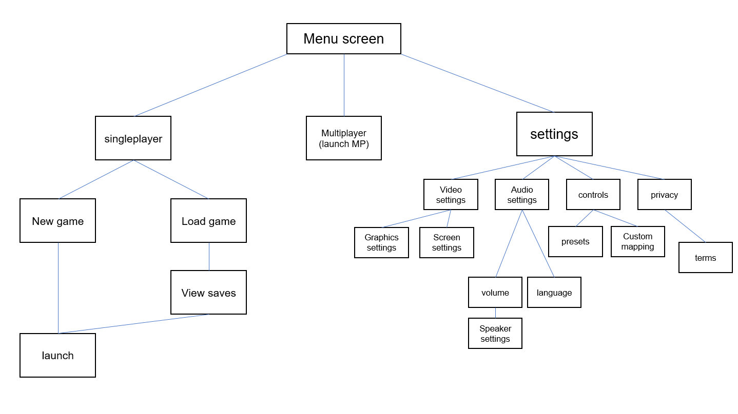

### In-game/Pause

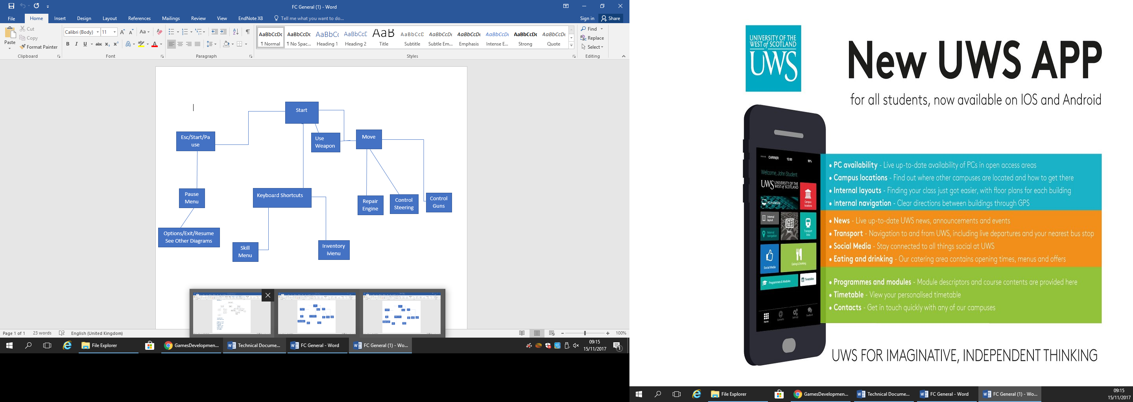

### Player Inventory

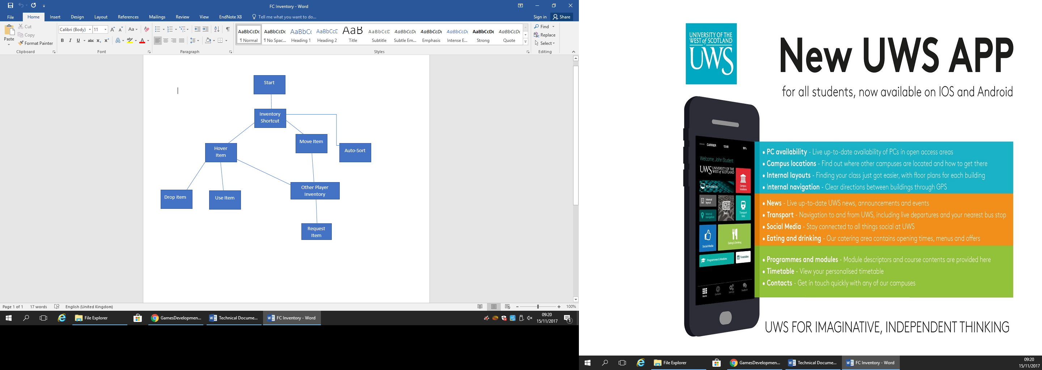

### Skill trees

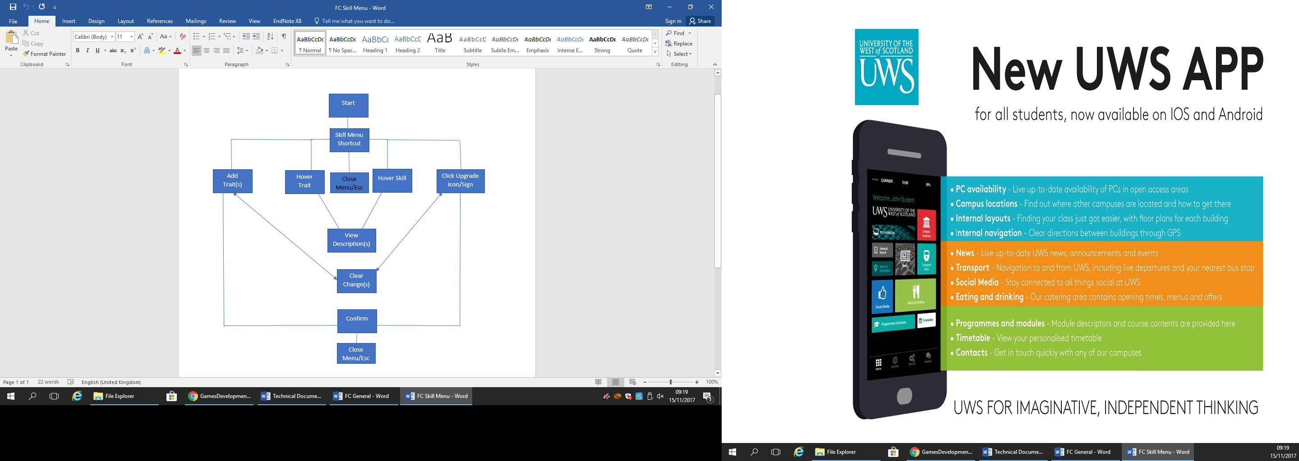

# Audio

## Features

* 2D/3D sound
* Full customisation of sound settings such as master volume, voice volume, music volume and general sound effects.
* Dynamic sound effects.
* Appropriate music for action moments.

### Volume control

The player will be able to access the volume control menu through the game settings. They will be able to customise volume settings through the use of sliders. The player can choose custom volume levels for in-game voices, sound effects, music and menu sounds. The player will also be able to choose speaker settings and be able to toggle subtitles for dialogue on and off.

### Speaker settings

The player will be able to choose what speaker set up they are using so the game can output its sound correctly. They will be able to choose between options such as TV speakers, external surround sound or headphones. The player will also be able to customise their microphone settings such as input volume and sensitivity.

### Headphones

If the player has chosen headphones as their output option they will be able to select the type of headphones they are using in order to maximise audio quality.